CL 2006 OPERATING SYSTEM

BS Software Engineering
Spring-2026

Course Instructors: Syed Daniyal Hussain Shah,Hifza Umer



Lab 12: Multithreading and thread attributes:

MultiThreaded Program:
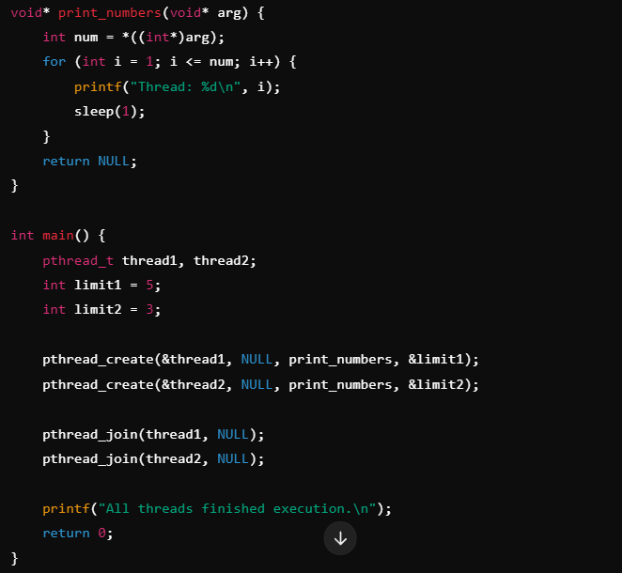
pthread_t thread1, thread2;: We declare two thread variables thread1 and thread2.
pthread_create(): This function creates a new thread. It takes the thread variable, some options (here NULL), the function to run, and the argument to pass to the function.
pthread_join(): This makes the main thread wait for the thread to finish before continuing.
sleep(1);: We add a small delay so the output is easier to follow.

Output:
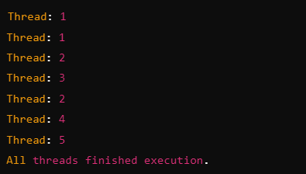
The order of execution can vary every time you run the program because the threads run independently.

Global variables;
Global variables are accessible to all threads since threads share the same memory space.

Example:
#include <stdio.h>
#include <pthread.h>

int global_counter = 0;

void* increment_global(void* arg) {
for (int i = 0; i < 5; i++) {
global_counter++;
printf("Thread incrementing global: %d\n", global_counter);
}
return NULL;
}

int main() {
pthread_t thread1, thread2;

pthread_create(&thread1, NULL, increment_global, NULL);
pthread_create(&thread2, NULL, increment_global, NULL);

pthread_join(thread1, NULL);
pthread_join(thread2, NULL);

printf("Final global counter: %d\n", global_counter);
return 0;
}

Output:
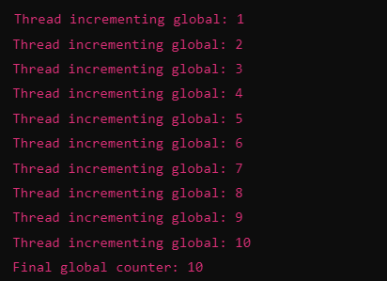
In this example, both threads modify the shared global variable global_counter.

Local Variables:
Local variables declared inside functions are thread-local by default, meaning each thread has its own copy of the local variables.

Example:
#include <stdio.h>
#include <pthread.h>

void* increment_local(void* arg) {
int local_counter = 0;
for (int i = 0; i < 5; i++) {
local_counter++;
printf("Thread local counter: %d\n", local_counter);
}
return NULL;
}

int main() {
pthread_t thread1, thread2;

pthread_create(&thread1, NULL, increment_local, NULL);
pthread_create(&thread2, NULL, increment_local, NULL);

pthread_join(thread1, NULL);
pthread_join(thread2, NULL);

return 0;
}

Output:
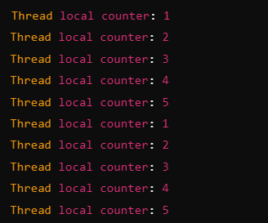
Here, each thread has its own copy of the local variable local_counter, and they do not interfere with each other.

Local Variable inside main Passed by Pointer:
If you want to modify a local variable declared in main(), you need to pass a pointer to that variable to the thread function. This way, the thread can directly modify the variable in main().

Example:
#include <stdio.h>
#include <pthread.h>

void* modify_local(void* arg) {
int* local_var_ptr = (int*) arg;
*local_var_ptr += 10;
printf("Thread: local_var = %d\n", *local_var_ptr);
return NULL;
}

int main() {
pthread_t thread;
int local_var = 20;

printf("Before thread: local_var = %d\n", local_var);

pthread_create(&thread, NULL, modify_local, (void*) &local_var);

pthread_join(thread, NULL);

printf("After thread: local_var = %d\n", local_var);
return 0;
}

Output:
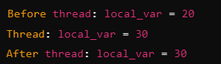

Local Variable inside main (Without Passing by Pointer):
If a local variable in main() is not passed by pointer (i.e., passed by value or not passed at all), modifying it in the thread will not affect the variable in main(). This is because the thread would be working with a copy of the variable, not the original one.

Example:
#include <stdio.h>
#include <pthread.h>

void* modify_copy(void* arg) {
int local_copy = *((int*) arg); // Copy the value, not reference
local_copy += 10;
printf("Thread: local_copy = %d\n", local_copy); // Change local copy
return NULL;
}

int main() {
pthread_t thread;
int local_var = 50; // Local variable in main

printf("Before thread: local_var = %d\n", local_var);

// Create thread and pass value of local_var (copying its value)
pthread_create(&thread, NULL, modify_copy, (void*) &local_var);

// Wait for thread to finish
pthread_join(thread, NULL);

printf("After thread: local_var = %d\n", local_var);
return 0;
}

Output:
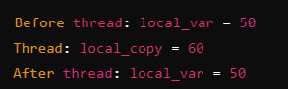
The thread modifies local_copy, which is a local copy of local_var, but it does not affect the original local_var in main() because the thread only received a copy of its value.

Multithreading Example:
Each thread runs a different function:
compute_sum1: Sums the first half of the array.
compute_sum2: Sums the second half of the array.
After both threads finish (pthread_join), the main thread adds the results (result1 and result2) to get the total sum.

Code:
#include <stdio.h>
#include <pthread.h>

#define SIZE 10

int result1 = 0;
int result2 = 0;

void* compute_sum1(void* arg) {
int* array = (int*)arg;
for (int i = 0; i < SIZE / 2; i++) {
result1 += array[i];
}
return NULL;
}

void* compute_sum2(void* arg) {
int* array = (int*)arg;
for (int i = SIZE / 2; i < SIZE; i++) {
result2 += array[i];
}
return NULL;
}

int main() {
int array[SIZE] = {1, 2, 3, 4, 5, 6, 7, 8, 9, 10};
pthread_t thread1, thread2;

pthread_create(&thread1, NULL, compute_sum1, (void*)array);
pthread_create(&thread2, NULL, compute_sum2, (void*)array);

pthread_join(thread1, NULL);
pthread_join(thread2, NULL);

int total_sum = result1 + result2;

printf("Total sum: %d\n", total_sum);

return 0;
}

Output:


Thread Attributes:
Thread attributes in POSIX threads (Pthreads) allow you to control various settings when creating threads. These attributes include properties like stack size, scheduling policy, thread detach state, and more. In pthread_create(), you can pass a thread attribute object that specifies these settings.
By default, if you pass NULL for the attribute parameter in pthread_create(), the thread is created with default attributes. However, if you want to customize the behavior, you can create and modify a pthread_attr_t structure.

Common Thread Attributes:

Detach State (PTHREAD_CREATE_JOINABLE or PTHREAD_CREATE_DETACHED):
Joinable Threads (default): You need to explicitly join the thread using pthread_join() to clean up resources.
Detached Threads: The thread will automatically release its resources when it finishes, and pthread_join() cannot be used on it.

Syntax:

Stack Size:
You can change the stack size allocated to the thread.

Syntax:

Example: Setting Thread Attributes:
In this example, we'll create a thread with modified attributes, specifically setting it as a detached thread with a custom stack size.

#include <stdio.h>
#include <pthread.h>

void* thread_function(void* arg) {
printf("Thread is running...\n");
return NULL;
}

int main() {
pthread_t thread;
pthread_attr_t attr;
size_t stacksize;

// Initialize thread attribute
pthread_attr_init(&attr);

// Set thread to be detached
pthread_attr_setdetachstate(&attr, PTHREAD_CREATE_DETACHED);

// Set custom stack size (e.g., 2MB)
stacksize = 2 * 1024 * 1024; // 2 MB
pthread_attr_setstacksize(&attr, stacksize);

// Create thread with custom attributes
pthread_create(&thread, &attr, thread_function, NULL);

// Destroy the attribute object, we no longer need it
pthread_attr_destroy(&attr);

// Since the thread is detached, we don't need to join it
printf("Main thread is done.\n");

// Let the main thread sleep for a while to let the detached thread run
sleep(1);

return 0;
}

pthread_attr_init():
Initializes a pthread_attr_t object with default values.
pthread_attr_destroy():
Destroys the attribute object to free resources.

Tasks:

- Implement a multithreaded calculator that performs addition, subtraction, multiplication, and division on two numbers concurrently
- Define global variables for the two numbers and results for each operation.
- Create separate functions for addition, subtraction, multiplication, and division.
- Each function will use global variables to get the input numbers and store the result.
- Create threads for each operation and wait for them to complete before printing the results.

- Implement a multithreaded calculator that calculates the square and square root of a number concurrently, without using global variables.
- Use local variables to store the input number and results for square and square root calculations.
- Create separate functions for calculating the square and square root of the number.
- Pass the input number and result pointer directly to each thread.

Task Submission Guidelines:
- Make a document and paste all tasks solution there (Not screenshot) and save it as pdf.
- Along with each task solution, also upload the screenshot of the output.
- Include your name and roll no. at the front page.
- Please submit your file in this format (Roll_number-name) i.e (24I-1234-Ali.pdf).
- Files other than pdf will not be accepted and will be marked as 0.

